Walk 21 Backbury Hill & Pentaloe Glen
Last walked in March 2016

Description. An 8 km (5 mile) walk over rolling country thru woods and farmland.
Start. From Swardon Quarry car park and picnic site 5 miles south east of Hereford. Map Explorer 189 Grid reference SO 578386.
Directions from the Fire Station. (Turn milometer to zero). With the Fire Station on your L. 200 yards passed the Fire Station TR signed 'Fownhope B4224'. After 3.9 miles, (in Mordiford) TL signed Dormington. After 4.8 miles TR signed for Checkley and a picnic site. After 200 yards the road continues on around to the L, a little further on you keep R and head on uphill for a further ½ mile to Swardon Quarry picnic site and car park, which is on your R. [5.5 miles]

1. Quarry Car Park. With your back to the quarry/car park TR, walk 10m up the road to TR onto a track that’s off to the R. Walk a few metres and TL (by a sign post for Mordiford Loop), and walk up hill, going thru a belt of wood-land. After 140m you reach another Mordiford Loop sign post where you TR and go thru a small metal gate and along a wide grassy path. Walk along this path for almost 1 km, going thru a gate, crossing a track and thru another gate, to continue on until you go thru a metal gate into a field {F1}. Keep to the fence on your R for about 70m, and then continue on thru a wide gateway gap into {F2}. Go downhill, keeping the fence/hedge on your L, to go thru a small metal gate at the bottom, into a wood. Follow the path thru the wood and downhill, (ignore a cross track that appears 15m down). Near the end of the wood you go down some wooden steps onto a metalled track. TR and go downhill to the main road.

2. Mordiford. TL and after 200 m, just past a wooden bench, TL at a Mordiford Loop Walk finger post and follow a narrow path to join a residential road. Mordiford is a village and a parish in the district and county of Hereford; the village stands on the river Lug, near its influx to the Wye, and is under Backbury hill. The village has a post office, (if still functional), a bridge over the river Lug, a pub (The Moon Inn), and a church. The church has Norman portions; is chiefly later English; has a transept rebuilt in 1852, and a tower rebuilt in 1814; has also a memorial window to the eldest daughter of R. Hereford, Esq.; and contains a piscina, an ancient monument, an effigies with a very ancient inscription, and a memorial of a very remarkable storm which passed over the village in 1811. The parish contains also the hamlets of Checkley, Checkley-Green, Sufton, and the Rock. After the third bungalow on the L, TL down a narrow fenced path to go thru a kissing gate into {F3}. Keep the Brook on your L as you walk along this long field, then along a stone chippings drive to reach a metal bridge at the end of {F3} where you TR and walk up to the top field corner that’s by a derelict cottage, to go thru a small wooden gate into Bear's Wood. After 50m into the wood you reach a wide track where you TL. Walk along the wide track until you emerge onto an open area at the end, (there is a metal bridge on your L that crosses the stream). Ignore the small track ahead that’s to the R of the stream and bear R to go uphill on the main forest road. After ½ km, when the road bends sharp R back on itself, in the far L corner of the bend you go into the woods and down a narrow path that leads to a stile into {F4}. Cross the stile, walk a few paces into the field and TR, now aim for the lowest corner of the wood ahead to cross another stile. Go into Limburies Wood and follow the footpath, keeping to the edge of the wood on your L until it emerges onto a main track. TL, cross the brook and walk along the track for about 30m to cross a stile on your R into {F5}.

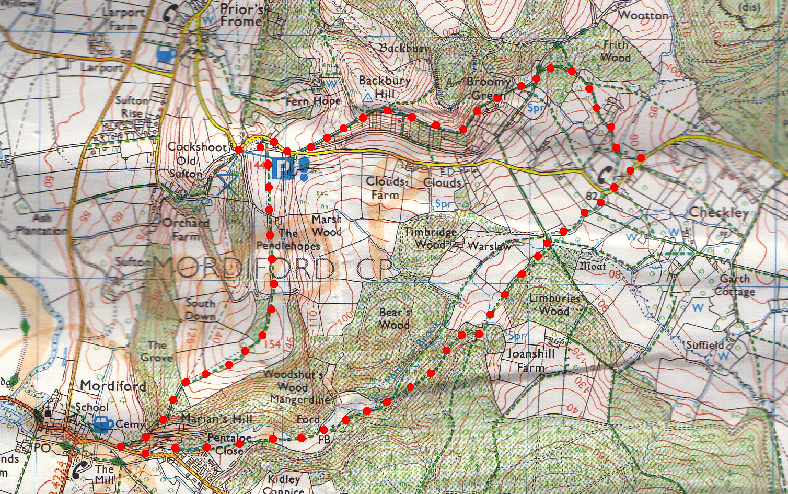
3. Stile. Follow the brook and cross a stile into {F6}. Follow the brook and cross a stile into {F7}. Follow the brook and go thru a small metal gate and along an enclosed track, to reach a minor road. TR and walk along the minor road that bends L, until you reach St Nicholas Checkley Chapel (L). 150m further up the road you TL (The FIRS house is opposite). Go thru a gate on the L and follow the enclosed track to go thru a gate and across a bridge over the brook. Follow a footpath between hedges into a wood. Once in the wood ignore all paths and tracks to both R and L and keep on the main track that converts into a stone chipping drive as it goes gently uphill, to emerge onto a wider track at a T-junction. TL and walk along the wide enclosed track for 30m to TR where the track forks before a cottage.
1
3
4
1
5

4. Track Fork. Go uphill on the track, after 150 m TR off the track onto a footpath signed 'Loop Walk' to continue uphill with a fence on the L. Stay on this main path for l km until you reach a track junction by a marker post and TL, (don’t go up the steps in front of you). Continue down hill to reach a minor road. TR for 50 m then TL off the road onto a grassy path into a belt of trees and follow this path back to the quarry.
2

